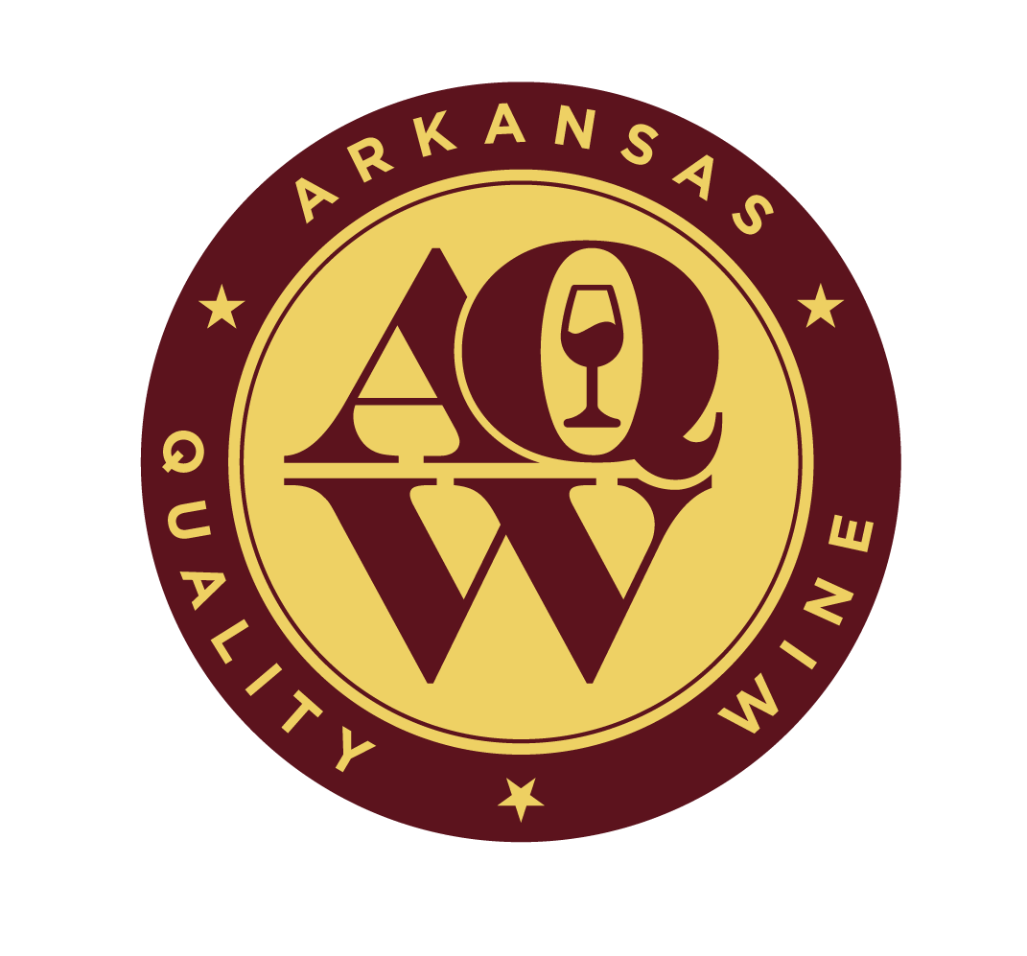
ARKANSAS QUALITY WINE (AQW)
2023 Wine Competition Entry Information
May 17-19, 2023

Wine Competition Date: May 17-19, 2023

Entry Deadline: May 10, 2023

Wine Competition Location: University of Arkansas System (UA System) Division of Agriculture, Food Science Department

Wine Competition Coordinator: Dr. Renee Threlfall

Wine Entry Fee: $25.00 per wine (Note: entry fee will be $50 per wine in 2024)

Wine Entry Quantity: Three (3) 750 mL bottles or 4 375 mL bottles of wine per entry for the AQW Competition and two (2) 750 mL bottles or (2) 375 mL bottles of wine per entry for the Arkansas Competition

Competition Types

- Arkansas Competition (Arkansas made)
- Wines for Entry: Produced in a commercial Arkansas winery, no minimum requirements for Arkansas grown grapes. Grapes must consist of Vitus vinifera, French/American hybrids or American varieties (Vitis labrusca, rotundifolia and aestivalis).
- Any fruit other than grapes including essence (formula) wines are not allowed.
- A minimum of 20 cases of wine should be available for sale at the time of entry.
- Limit five (5) wine entries per winery.

- Arkansas Quality Wine Competition (Arkansas grown and made)
- Wines for Entry: Produced in a commercial Arkansas winery and made of 90% Arkansas grown grapes consisting of Vitus vinifera, French/American hybrids or American varieties (Vitis labrusca, rotundifolia and aestivalis).
- Any fruit other than grapes including essence (formula) wines are not allowed.
- A minimum of 20 cases of wine should be available for sale at the time of entry.
- No limit on entry per winery.

Wine Sensory Evaluation:
- A panel of three experienced judges will use a modified 20- point University of California, Davis wine competition scoring system. The scores will be averaged and rounded to the next full number.
- Wines for the AQW program must receive 15 points or higher on a 20-point scale to be eligible for the AQW seal. Participating wineries will be contacted by the AQW with results of the sensory and chemical evaluation.
- Sensory evaluation will be done at the UA System Food Science Department.

Wine Chemical Evaluation (for AQW eligible wines only):
- In addition to earning 15+ points in the competition, wines for the AQW program must pass chemical evaluation based on Federal (TTB) standards for volatile acidity, total sulfur dioxide and alcohol levels.
- Chemical analyses will be done at the UA System Food Science Department.

Wine Category:
- An overall wine category is required on the entry form, if needed, a subcategory can also be listed. There might be overlap but choose the best option of category for the wine.
- If the wine is varietal, please indicate on the entry form. Varietal wines will be separated within each category.
- If the wine is generic, please indicate from which varieties the blend is made.

Sweetness designations:
- Dry=under 0.7% residual sugar (RS)
- Medium Dry=0.8-2.0% RS
- Medium Sweet= 2.1-4.0% RS
- Sweet=more than 4.0% RS

Vintage of Wines: The vintage on the entry form has to be consistent with the label! If there is no vintage designation on the label, the space on the entry form should be left empty or stated as Non-Vintage.

Ship or Bring Wines Week Prior to the Competition:
Dr. Renee Threlfall
AQW Wine Competition
UA System Food Science Department
2650 N. Young Avenue
Fayetteville, AR 72704
479-575-4677, rthrelf@uark.edu

Payment Information: Pay for entries to the AQW wine competition by credit card on the Arkansas Association of Grape Growers website (https://www.argrapegrowers.org/arkansas-quality-wine-program ) or send a check made payable to the Arkansas Association of Grape Growers to the shipping address. .

ARKANSAS QUALITY WINE PROGRAM

2023 Wine Competition Wine Categories
The AQW wine competition overall categories and subcategories for the wine competition entry form are listed below. An overall category is required, then select a subcategory if needed. There might be overlap but choose the best option for the wine.
Overall Categories

American Red
American White
American Blush/Rose
Hybrid Red
Hybrid White
Hybrid Blush/Rose
Vinifera Red
Vinifera White
Vinifera Blush/Rose

Subcategories

Concord
Cynthiana/Norton
Muscadine Red
American Dry Red
American Medium Dry Red
American Medium Sweet Red
American Sweet Red
White Catawba
Niagara
Muscadine White
American Dry White
American Medium Dry White
American Medium Sweet White
American Sweet White
Pink Catawba
American Dry Blush/Rosé
American Medium Dry Blush/Rosé
American Medium Sweet Blush/Rosé
American Sweet Blush/Rosé
Chambourcin
Chancellor
Enchantment
Foch
Noiret
Hybrid Dry Red
Hybrid Medium Dry Red
Hybrid Medium Sweet Red
Hybrid Sweet Red
Cayuga
Chardonel
Dazzle
Frontenac Gris
Indulgence
Opportunity
Seyval
Traminette
Valvin muscat
Vidal
Vignoles
Hybrid Dry White
Hybrid Medium Dry White
Hybrid Medium Sweet White
Hybrid Sweet White
Hybrid Dry Blush/Rosé
Hybrid Medium Dry Blush/Rosé
Hybrid Medium Sweet Blush/Rosé
Hybrid Sweet Blush/Rosé
Pinot Noir
Cabernet Sauvignon & blends
Cabernet Franc
Merlot
Shiraz/Syrah
Vinifera Dry Red
Vinifera Medium Dry Red
Vinifera Medium Sweet Red
Vinifera Sweet Red
Pinot Gris/Grigio
Chardonnay
Gewurztraminer
Riesling
Vinifera Dry White
Vinifera Medium Dry White
Vinifera Medium Sweet White
Vinifera Sweet White
Vinifera Dry Blush/Rosé
Vinifera Medium Dry Blush/Rosé
Vinifera Medium Sweet Blush/Rosé
Vinifera Sweet Blush/Rosé
American Sparkling
Hybrid Sparkling
Vinifera Sparkling
Dessert: Fortified, dry or sweet
Slightly Carbonated

2023 ARKANSAS QUALITY WINE PROGRAM

Wine Competition Entry Form

Winery Information
Winery Name
Contact Person
Street Address
City, State, ZIP
Phone
Email
Bonded Winery Permit Number
Signature and date (required)
The signee ensures that this wine was made in Arkansas and if submitted for the AQW competition that the wine was made from 90% grapes grown in Arkansas.
Wine Entry (check one of the following)
___ Arkansas Competition ___Arkansas Quality Wine Competition
Overall Category (required):
Subcategory:
Wine Name:
Brand (If other than Winery Name):
Vintage:
Percent Alcohol
Varietal / Generic Name
Blend Components
Percentages of grapes used in varietal or blend
Appellation (as stated on label)
Percent Residual Sugar (RS)
Dry=< 0.7%; Medium Dry=0.8-2.0%; Medium Sweet= 2.1-4.0%; and Sweet=>4.0%
Appellation:
Location Grapes Purchased/Grown
Vineyard name or city
Total Gallons of Wine Produced
Number of Cases Available for Sale

Wine Entry Form: Use one form per wine and forms should be sent with wines. For additional AQW Wine Competition entry forms, visit the Arkansas Association of Grape Growers (AAGG) website (https://www.argrapegrowers.org/arkansas-quality-wine-program) to print a form or make photocopies of this form.
Payment: Pay for entries to the AQW wine competition by credit card on the AAGG website or send check payable to AAGG to the shipping address.
Ship or Bring Wines and Entry Forms to: Dr. Renee Threlfall, AQW Wine Competition, UA System Food Science Department, 2650 N. Young Avenue, Fayetteville, AR 72704, 479-575-4677, rthrelf@uark.edu

